Contents

Nexus Dashboard Insights Value for ASML 1

Monitoring and Visibility: 2

Automation: 2

Automated Anomaly Detection: 2

Configuration Automation: 2

Lifecycle Management (LCM): 3

Software Upgrades: 3

Change Management: 3

Integration with Third-Party Tools: 4

Specific Use Cases: 4

Support for ACI Automation 4

Asset Tracking and Management: 4

Configuration Management: 4

For Lifecycle Management (LCM) 4

Software Version Management: 4

Maintenance Operations: 5

Upgrade Management: 5

Environmental Considerations: 5

Monitoring Data Center Environment: 5

Environmental Impact Analysis 5

*Assurance* 5

*Endpoint Analysis* 5

*Interface Statistics:* 5

FLOW ANALYTICS if we have time. 6

***Flow Check*** 6

Nexus Dashboard Insights Value for ASML  
  
These use cases on areas such as Monitoring, Automation, Operations, Lifecycle Management (LCM), Software Upgrades, and the specific use of verifying changes before and after with NDI.  
Executive Summary:  
Overall, NDI is a comprehensive tool that enhances network operations through detailed monitoring, analysis, and proactive problem resolution, contributing significantly to the overall efficiency and reliability of the network infrastructure.

# Monitoring and Visibility:

Real-Time Health Monitoring: Utilize NDI to monitor the health of the data center network in real-time, identifying issues such as abnormal traffic patterns or device failures.

Environmental Impact Monitoring: Track and analyze environmental factors impacting network performance, like temperature fluctuations.

# Automation:

Automated Anomaly Detection: Deploy NDI for automated detection of network anomalies, reducing the need for manual monitoring.

Configuration Automation: Use NDI to automate repetitive configuration tasks, ensuring consistency and reducing human error.  
  
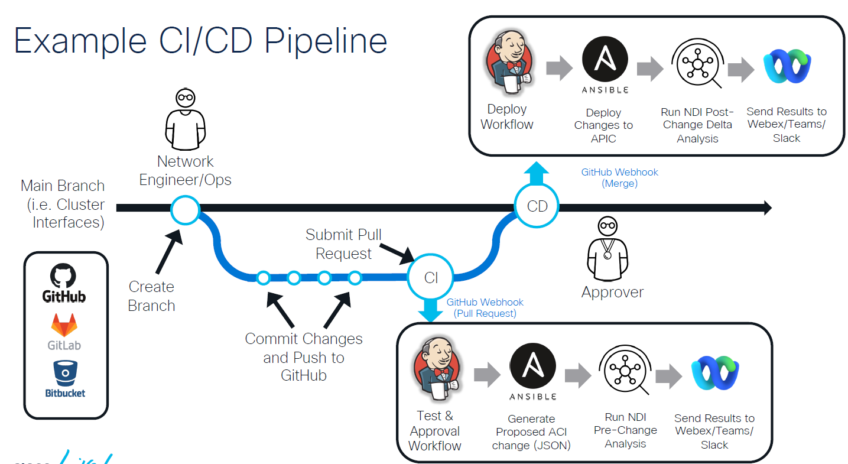

Operations:  
  
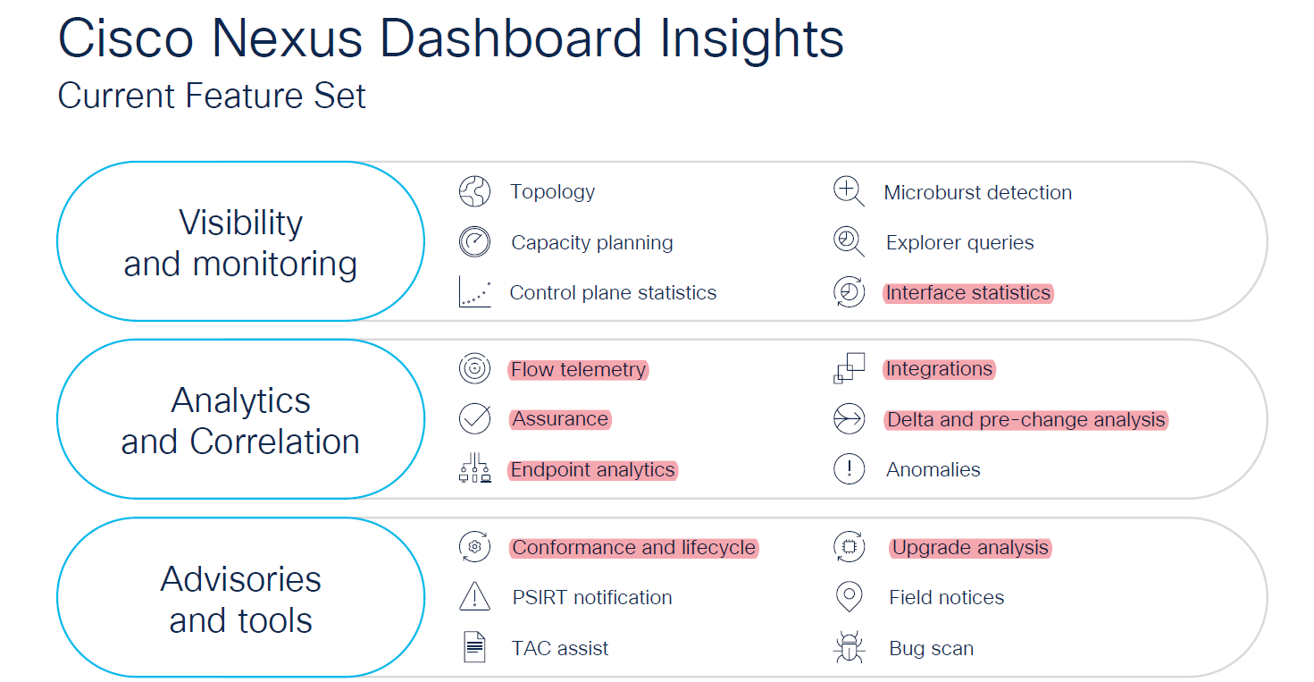

Proactive Advisories: Leverage NDI’s capabilities to receive proactive advisories on potential issues, allowing preemptive action to avoid network downtimes.

Troubleshooting Support: Utilize NDI's detailed insights for faster and more efficient troubleshooting of network issues.

# Lifecycle Management (LCM):

Asset and Configuration Management: Implement NDI for asset tracking and configuration management across the data center, ensuring compliance and up-to-date records.

Maintenance Operations: Schedule and manage maintenance tasks effectively using insights provided by NDI.

# Software Upgrades:

Upgrade Impact Analysis: Before implementing software upgrades, use NDI to analyze potential impacts on the network to mitigate risks.

Firmware Upgrade Analysis: Using NDI's insights, evaluate and manage firmware upgrades for network devices.

# Change Management:

Pre-Change and Post-Change Analysis: Utilize NDI to assess network status and performance before and after changes are made to ensure stability and intended outcomes.

Compliance Checks: Regularly perform compliance checks using NDI to ensure that network configurations adhere to organizational and industry standards.

# Integration with Third-Party Tools:

**~~ServiceNow and Splunk Integration~~**~~:~~ Integrate NDI with platforms like ServiceNow and Splunk for enhanced incident management and data analytics.

# ~~Specific Use Cases:~~

Verify Changes Before and After Implementation: Utilize NDI to compare network configurations and performance metrics before and after changes, ensuring that modifications achieve desired outcomes without unintended consequences.

~~Support for ACI Automation~~: Employ NDI as a pre-check tool in your CICD pipeline to support ACI automation, ensuring that configurations are correct before deployment.

These use cases demonstrate the versatility of Nexus Dashboard Insights in enhancing network monitoring, automation, operations, lifecycle management, software upgrades, and change management processes in a data center environment. you can leverage these use cases to discuss NDI's potential benefits and applications with internal stakeholders.

## Asset Tracking and Management:

Inventory Management: Utilize NDI for comprehensive visibility into the data center's network assets, including hardware and software components. NDI can provide detailed insights into device types, models, operating systems, and configurations.

Resource Utilization Monitoring: Track the usage of network resources, like bandwidth, storage, and processing power. NDI can help identify underutilized or overutilized assets, facilitating better resource allocation.

## Configuration Management:

Automated Configuration Tracking: Leverage NDI to maintain a record of network configuration changes. This capability helps in auditing, ensures consistency across the network, and aids in troubleshooting.

Compliance Verification: Use NDI to regularly check network configurations against predefined compliance standards and policies, ensuring adherence to internal and external regulatory requirements.

For Lifecycle Management (LCM) in a data center environment, leveraging Cisco's Nexus Dashboard Insights (NDI) can significantly enhance efficiency and effectiveness. Here's a detailed outline of the LCM use case with NDI:

Lifecycle Management (LCM) Use Case with Nexus Dashboard Insights

## Software Version Management:

Firmware and Software Updates: Monitor and manage firmware and software versions across network devices. NDI can assist in identifying outdated software, scheduling updates, and verifying successful deployments.

Golden Image Management: Maintain and deploy standardized configurations or ‘golden images’ for network devices. NDI can help ensure that all devices are running the optimal configurations for performance and security.

# Maintenance Operations:

Scheduled Maintenance Planning: Utilize NDI’s insights for planning and executing scheduled maintenance activities. Predictive analytics can forecast potential issues, allowing for preemptive maintenance work.

Downtime Minimization: Leverage NDI’s analytics to schedule maintenance activities during off-peak hours, minimizing the impact on business operations.

# Upgrade Management:

Impact Analysis for Upgrades: Before implementing upgrades, use NDI to analyze potential impacts on the network. This proactive approach helps in identifying risks and planning for contingencies.

Post-Upgrade Verification: After upgrades, use NDI to verify that network performance is stable and that the enhancements have been implemented successfully.

# Environmental Considerations:

Monitoring Data Center Environment: Use NDI to monitor environmental factors within the data center, like temperature and humidity, which can affect equipment performance and longevity.

Environmental Impact Analysis: Analyze data collected by NDI to make adjustments that optimize the data center’s environmental conditions, leading to enhanced equipment lifespan and reduced energy consumption.

Assurance: *NDI offers network assurance capabilities by continuously monitoring the network's health and performance. It uses advanced analytics to detect issues proactively and can suggest remediation steps, ensuring the network operates optimally and meets the defined intents.*

*Endpoint Analysis: NDI can track and analyze the behavior of endpoints connected to the network. This includes monitoring endpoint health, traffic patterns, and detecting any unusual activities that might indicate security risks or performance issues. Individual network interfaces and for troubleshooting issues related to network congestion or hardware malfunctions.*

*Interface Statistics: NDI provides detailed statistics on network interfaces, such as utilization rates, error rates, and other critical metrics. This data is crucial for assessing the performance of*

# FLOW ANALYTICS if we have time.

***Flow Check: NDI can monitor and analyze network traffic flows within your data center. It provides*** *visibility into the flow of data between different endpoints, helping in identifying any anomalies or inefficiencies in network traffic.*